Python Output:

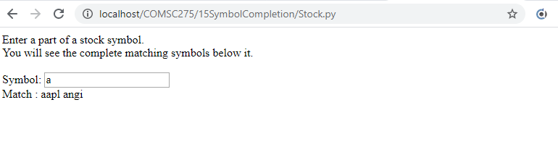

Stock.py

#!/Python27/python  
  
import cgi  
  
print("Content_type: text/html\n\n")  
print('''  
  
<html>  
  
<head>  
  
<script>  
  
// create XMLHttpRequest object as a global variable  
var myReq = new XMLHttpRequest();  
  
// The function below is invoked on pressing any key and releasing it  
// in text field.  
// It communicates with object XMLHttpRequest to perform ajax  
// It sets up in the object the callback method to be called and the  
// url of the script to be invoked and query string to be passed to it.  
// The query string contains partially typed symbol and a random number.  
// The random number is used to make the url unique and avoid  
// getting the cached response.  
function searchStock(value,event) {  
 //alert ("searchStock");  
 myReq.onreadystatechange = searchStockCallback;  
  
 var thePage = "SearchStock.py";  
 var theURL = thePage +"?symbol=" + value;  
  
 myRand = parseInt(Math.random()*999999999999999);  
  
 theURL = theURL +"&rand="+myRand;  
  
 myReq.open("GET", theURL, true);  
 //alert ("searchStock2");  
 myReq.send(null);  
 //alert ("searchStock3");  
}  
  
  
// The following callback function is called by object XMLHttpRequest  
// whenever its ready state changes. When ready state is 4  
// (i.e. request is completed) and HTTP status is 200 (i.e. OK),  
// it copies the script response in the span.  
function searchStockCallback() {  
 //alert ("searchStockCallback "+myReq.readyState);  
 //alert ("searchStockCallback "+myReq.status);  
 if (myReq.readyState == 4 && myReq.status == 200) {  
 //alert ("searchStockCallback-Ready");  
 document.getElementById("idStockGuess").innerHTML =  
 myReq.responseText;  
 }  
}  
  
  
//The following function is invoked on clicking the span.  
//It copies the content of the span (i.e. script response) to text field.  
function setStock(stock){  
 document.getElementById("idStock").value = stock;  
}  
  
</script>  
  
</head>  
  
<body>  
  
Enter a part of a stock symbol.<br>  
You will see the complete matching symbols below it.<br>  
<br>  
  
Symbol: <input type="text" id="idStock"   
 onkeyup="searchStock(this.value,event);" /><br>  
Match : <span id="idStockGuess"  
 onclick="setStock(this.innerHTML);"></span><br>  
  
</body>  
  
</html>  
''')

SearchStock.py

#!/Python27/python  
  
import cgi  
  
print("Content_type: text/xml\n\n")  
  
symList = ["aapl", "msft", "goog", "googl", "ibm", "angi"]  
f = cgi.FieldStorage()  
sym = f.getvalue("symbol")  
matches = ""  
for symbol in symList:  
 if len(sym) > 0 and len(symbol) >= len(sym):  
 sym = sym.lower()  
 symbol = symbol.lower()  
 if sym == symbol[0:len(sym)]:  
 if matches == "":  
 matches = symbol  
 else:  
 matches = matches + " " + symbol  
if matches == "":  
 matches = "No Match"  
  
print(matches)

PHP Output

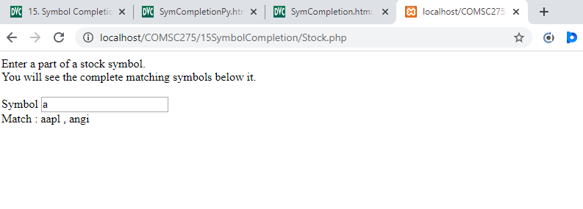

Stock.php

<html>

<head>

<script>

// create XMLHttpRequest object as a global variable

var myReq = new XMLHttpRequest();

// The function below is invoked on pressing any key and releasing it

// in text field.

// It communicates with object XMLHttpRequest to perform ajax

// It sets up in the object the callback method to be called and the

// url of the script to be invoked and query string to be passed to it.

// The query string contains partially typed symbol and a random number.

// The random number is used to make the url unique and avoid

// getting the cached response.

function searchStock(value,event) {

myReq.onreadystatechange = searchStockCallback;

var thePage = "searchStock.php";

var theURL = thePage +"?symbol=" + value;

myRand = parseInt(Math.random()*999999999999999);

theURL = theURL +"&rand="+myRand;

myReq.open("GET", theURL, true);

myReq.send(null);

}

// The following callback function is called by object XMLHttpRequest

// whenever its ready state changes. When ready state is 4

// (i.e. request is completed) and HTTP status is 200 (i.e. OK),

// it copies the script response in the span.

function searchStockCallback() {

if (myReq.readyState == 4 && myReq.status == 200) {

document.getElementById("idStockGuess").innerHTML =

myReq.responseText;

}

}

//The following function is invoked on clicking the span.

//It copies the content of the span (i.e. script response) to text field.

function setStock(stock){

document.getElementById("idStock").value = stock;

}

</script>

</head>

<body>

Enter a part of a stock symbol.<br>

You will see the complete matching symbols below it.<br>

<br>

Symbol <input type="text" id="idStock"

onkeyup="searchStock(this.value,event);" /><br>

Match : <span id="idStockGuess"

onclick="setStock(this.innerHTML);"><br>

</body>

</html>

SearchStock.php

<?php

// Fill the array with stock symbols

$list[]="aapl";

$list[]="msft";

$list[]="goog";

$list[]="ibm";

$list[]="wfm";

$list[]="sfm";

$list[]="tfm";

$list[]="bac";

$list[]="wfc";

$list[]="hpq";

$list[]="orcl";

$list[]="intc";

$list[]="angi";

$list[]="bbry";

$list[]="fb";

$list[]="hd";

$list[]="m";

//get the partial symbol if provided

if (isset ($_REQUEST["symbol"])){

$symbol=$_REQUEST["symbol"];

}

else {

$response="no match";

exit;

}

$matches="";

//check for all matches in the list array with user supplied symbol

if (strlen($symbol) > 0){

for($i=0; $i<count($list); $i++){

if (strtolower($symbol)

== strtolower(substr($list[$i],0,strlen($symbol)))){

if ($matches==""){

$matches=$list[$i];

}

else{

$matches=$matches." , ".$list[$i];

}

}

}

}

// Set output to "no match" if no matches were found

// Otherwise set output to the matched list.

if ($matches == ""){

$response="no match";

}

else{

$response=$matches;

}

//output the response

print $response;

?>